**Product Design Practice (INT_303)**



**Project Report**

**Group – B2-29**

**Topic – Farm-Monitor**

**Low-Cost Wireless Farm Monitoring System**

**Authors –**

**Atharva Baste – MSM19B024**

**KM Himanshu – CED19I026**

**Swapnil Paranjape – MFD19I003**

**Abstract –**

Efficient ways of farming are very rarely seen as most of the farmers nowadays lack important information on basic points of farming and trusting blindly on inappropriate sources. This can have a great impact on the outcome of total harvest and quality of harvest at the end of the season. What we are offering to give is accurate and live information about the consumer’s farm. Our product will be easy to install in various parts of the farm and will collect the ate from respective parts of the farm and display the necessary information like temperature, humidity, moisture content in soil, etc., using IoT (Internet of Things) on the app developed by the team. The app will be easy to install and will be available on both play store (for Android) and App Store (for IOS). The IoT (Internet of Things) is basically a system o interrelated devices connected to a network and / or to one another, exchanging data without necessarily requiring human-to-machine interaction.

**Contents –**

|  |  |  |
| --- | --- | --- |
| **Sr. No.** | **Title** | **Page No.** |
| 1 | Abstract | 2 |
| 2 | Introduction | 4 |
| 3 | Overview | 4 |
| 4 | Solution | 5 |
| 5 | About The Sensors | 6 |
| 6 | Requirements | 7 |
| 7 | Simulation in Tinker CAD and CAD model | 9 |
| 8 | Working Principle | 10 |
| 9 | Group Planning | 11 |
| 10 | Screenshots and Repos | 12 |
| 11 | Power Calculations | 15 |
| 12 | Observations | 15 |
| 13 | Future Enhancements | 15 |
| 14 | Bibliography | 16 |

**Introduction –**

Our economy relies heavily on farming. A farm's ecology is delicate. A wide range of external and environmental variables might negatively impact a farm's prospective productivity. Crop yield is significantly reduced because of inefficient irrigation patterns and a lack of real-time farm data. Irrigation management is critical for excellent yields and avoiding stress caused by water scarcity or excess. It is not easy to figure out when to irrigate. Previous experiences are uncertain, and they are frequently unadjusted for seasonal variations in weather. This can make scheduling based on weather data unreliable. So, the aim is to create a low-cost, automated model for monitoring and regulating the moisture content of a soil sample, primarily to meet the demands of rural farmers who are technologically illiterate.

Three main goals are looked to be fulfilled by following the solution we propose –

1. **Conserving the environment and preventing pollution –** Farmers will minimise their dependency on non-renewable energy, cut chemical use, and save rare resources by adopting sustainable methods. When considering the expanding population and need for food, keeping the land healthy and refilled may go a long way.
2. **Reducing costs and focus on profits –** Everyone involved in the agricultural business will gain from farming smarter and transporting food from farm to fork in a more efficient manner by depending on the sensor data from the soil via the device / technology that we provide to the consumer’s smart phone turns surprises into rarities.
3. **Improving food production without being wasteful –** The expected population growth is a main reason for concern. From a pure production viewpoint, there is a chance to expand agricultural techniques now, and sustainable agriculture is the option with the most potential.

**Overview –**

Farmers' information demands are rarely discussed with them, and their information search tactics are typically misunderstood. As a result, public agricultural extension programmes frequently fail. The following questions must be addressed while considering and executing extension programmes and consulting services:

* What data do the farmers require?
* What methods do they use to find information, and where do they look for it?
* What variables influence their search patterns?
* What is the maximum price they are prepared to pay for information?

While the first two concerns have been well addressed in the literature, the last two have yet to be answered in the context of developing nations. We look at farmers' information demands and search behaviour, as well as the factors that influence their search behaviour and their willingness to pay for information, using a case study of two districts in India. Cluster study of information sources' accessibility, frequency, and usage.

Thanks to GPS and the Internet, many farmers have been collecting data about their farms – water usage, inputs, crop yields – for over 20 years. Only in recent years has the term “big data” taken on a new meaning, given the plethora of new tools and technologies available today to help farmers collect and analyse data on all aspects of their farm operations. Here are four major benefits of measuring farm practices with the technologies available today –

1. Farmers may benefit from measurement data by better managing their operations; the more information they have, the better decisions they can make that are suited to their farm's individual needs.
2. Farmers may utilise the data to find efficiencies that lead to increased production and profitability, cheaper input costs, and better fertiliser usage.
3. The more information a farmer has about his or her farm, the greater his or her chances of improving supply chain partnerships are. Data assists farmers in reducing volatility and risk, which benefits both the grower and the supplier. As a result, the supplier is more likely to deal with that farmer on a long-term basis. At the same time, the data enables the manufacturer to collaborate with the supply chain to help enterprises and retailers improve ingredient transparency.
4. Farmers may tackle conservation at a landscape size rather than a farm or even a county level thanks to data collecting. Growers will have more possibilities to collaborate with others at a watershed size to make educated decisions about conservation goals if they have more information.

**Solution –**

Since we can clearly see that the agricultural platform needs an intelligent software system for data acquisition from a particular farm which has high requirements for the input interface, such as fast data input speed, and unnecessary data information should be removed during input. Thanks to GPS, modern science, and technology on agricultural production efficiency we are able to build a product which will provide some basic information about their farms and also give real time data to the consumer / farmers about the abnormalities to take care of in their farms and also proposing the plausible solutions to take care of the crops for effective farming and help in significant changes in total yield of the farm.

The solution we propose is to monitor real-time farm conditions and use that information to help the farmer produce a better yield. Farm-Monitor will collect data from the vicinity, analyse the collected data and send it to the farmer's mobile phone. Farm-Monitor will keep track of the acidity of the soil, moisture content, temperature, humidity present in the air and will also be on the lookout for any potential anomaly. If any potential content is out of order for that particular crop Farm-Monitor will also suggest potential steps to be taken in order to fix the condition. In the next phase we have plan to add functionality so that irrigation is linked to the moisture content tracker directly, without any human intervention. With the help of Farm-Monitor a farmer will be able to manage his farm in an effective way.

The solutions, the problems and the real time tracking data of the farm conditions will be provided to the farmers in their smart phones simply by downloading our app which will be easy to use and help get the information under the fingertips of the farmers. The vital information that we plan to provide to our consumers are

* Testing moisture in the soil.
* Testing Temperature of the soil.
* Checking Humidity in the air.

Farm Monitor lets you know what's going on in your farm all the time. Whether you are a novice gardener or run a farm, Farm Monitor is here to take on the task of guessing the garden. Embedded in the soil, our sensors collect and analyse data on climate change and soil conditions. The Farm Monitor App presents this data as a real-time summary of your garden / farm and pushes warnings and suggestions to extend plant life.

Providing the optimum level of these and other materials needed for maximum productivity with just our phones from remote areas it solves the food shortages around the globe.

**Rough Sketch –**

**About The Sensors –**

**Soil moisture sensor –**

A small charge is placed on the electrodes and electrical resistance through the sensor is measured. As water is used by plants or as the soil moisture decreases, water is drawn from the sensor and resistance increases. Conversely, as soil moisture increases, resistance decreases. It is compatible with the Arduino uno and can be placed at an optimal depth.

**DHT-11 sensor –**

The DHT11 is an ultra-low-cost digital temperature and humidity sensor. It uses a capacitive humidity sensor and a thermistor to measure the surrounding air and sends out a digital signal on the data pin. DHT-11 sensor is compatible with the Arduino uno.

Although India is the second largest irrigated country of the world after China, only one-third of the cropped area is under irrigation. Irrigation is the most important agricultural input in a tropical monsoon country like India where rainfall is uncertain, unreliable at the same time availability for water for irrigation is not easy to get, that's why it's important to know when to irrigate land before crops get damaged.

It is known that lack of information about farm crops sometimes leads to bad yield of crops, farmers have no real time vital details about their land and crop. It has been seen that if they knew about the issue at the right time they could have solved those problems with some proper guidance. If the farmers have real time data about vital compositions like moisture, pH or temperature that are required for certain crops, then they can monitor those and take right steps accordingly.

**Requirements –**

**Cloud Server –**

For Sending the results and acquired inputs from sensors we need some sort of cloud server so that from there we can send desired output to the user dashboard. It’s easy to get cloud servers even though we can get some free hosting servers for testing purposes.

**Node MCU ESP8266 –**

Node MCU is an open-source Lua based firmware and **development board** specially targeted for IoT based Applications. It includes firmware that runs on the ESP8266 Wi-Fi SoC from Espressif Systems, and hardware which is based on the ESP-12 module.

**Sensor –**

We need some sort of input devices for the Arduino board and sensors made for such work. There are a variety of sensors for different purposes like water moisture, temperature etc. These sensors take input values from the surroundings and send them to an Arduino microcontroller to process them.

Types of Sensors needed –

**Soil moisture sensor –**

A small charge is placed on the electrodes and electrical resistance through the sensor is measured. As water is used by plants or as the soil moisture decreases, water is drawn from the sensor and resistance increases. Conversely, as soil moisture increases, resistance decreases. It is compatible with the Arduino uno and can be placed at an optimal depth.

The fork-shaped probe with two exposed conductors, acts as a variable resistor (just like a potentiometer) whose resistance varies according to the water content in the soil.

This resistance is inversely proportional to the soil moisture:

* The more water in the soil means better conductivity and will result in a lower resistance.
* The less water in the soil means poor conductivity and will result in a higher resistance.

The sensor produces an output voltage according to the resistance, which by measuring we can determine the moisture level.

**DHT-11 sensor –**

The DHT11 is an ultra-low-cost digital temperature and humidity sensor. It uses a capacitive humidity sensor and a thermistor to measure the surrounding air and sends out a digital signal on the data pin. DHT-11 sensor is compatible with the Arduino uno.

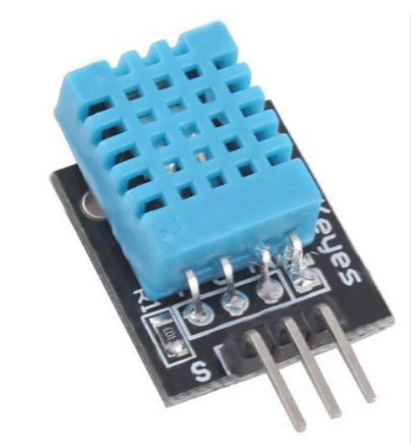

The DHT11 is a commonly used Temperature and humidity sensor that comes with a dedicated NTC to measure temperature and an 8-bit microcontroller to output the values of temperature and humidity as serial data. The sensor is also factory calibrated and hence easy to interface with other microcontrollers. The sensor can measure temperature from 0°C to 50°C and humidity from 20% to 90% with an accuracy of ±1°C and ±1%.

**Simulation in Tinker Cad and Cad model –**

**Working Principle –**

The device, using an array of sensors, collects information about the environmental factors and soil conditions. The DHT-11 sensor collects data about the air temperature and humidity and the soil moisture sensor using the principle of capacitance collects information about the moisture content in the soil. All the data that is collected is then sent for information extraction and interpretation.

This is achieved by sending the data to an Arduino / Node MCU microcontroller, the microcontroller then checks the data and automates the irrigation process to achieve optimal irrigation to ultimately boost agricultural yield. The node MCU Wi-Fi module which is in built in node MCU ESP8266 then used to send the data collected from the sensors to our live database where it is analysed, and meaningful insights are drawn. These insights are then sent to our application where it will be displayed and conveyed to our customer in a very user-friendly way. Farm monitor will also suggest practices based on the data to further help increase the output.

Farm monitor will help negate the randomness of nature and help bring consistency to farming.

**Group Planning –**

**Milestones efficiently achieved during this project –**

* Feb 14-Research on Automation of irrigation (via switch)
* Feb 22-Component procurement (all by Feb 22)
* Feb end-Complete simulation of sensors(virtual)
* Testing bought sensors(physical)
* March 15-ESP8266 module integration
* March 22-Backend development & Frontend Development
* March end-Assembly of parts of product
* April Week 2-Integration of backend with frontend,
* April Week 3-Final testing
* April end-Project complete

**Work Distribution –**

|  |  |  |  |
| --- | --- | --- | --- |
|  | Task Title | Allotted Person | Duration (Weeks) |
| 1 | Design Testing, Procurement, and Initialization – |  | 11 |
| 1.1 | Gather all required sensors. | Swapnil | 2 |
| 1.2 | Do a compatibility test. | Atharva, Swapnil | 1 |
| 1.3 | Use proteus to test circuit. | Atharva, Swapnil | 2 |
| 1.4 | Soil sensors Arduino code. | Himanshu | 2 |
| 1.5 | DHT-11 sensor Arduino code. | Atharva | 2 |
| 1.6 | CAD Model. | Swapnil | 1 |
| 1/7 | Simulation. | Atharva, Swapnil | 1 |
| 2 | Integration – |  | 11 |
| 2.1 | Hardware circuit connections. | Atharva | 2 |
| 2.2 | Fabrication. | Atharva | 1 |
| 2.3 | Heat management in circuitry. | Atharva, Swapnil | 1 |
| 2.4 | UI / UX design. | Himanshu | 3 |
| 2.5 | Back-end design. | Atharva , Himanshu | 3 |
| 2.6 | Integration of front-end and back-end. | Himanshu, | 1 |
| 3 | Project Launch and Execution – |  | 4 |
| 3.1 | Final testing. | Everyone | 2 |
| 3.2 | Bug fixes. | Everyone | 2 |

**Screenshots and Repos –**

<https://github.com/TheOxFromOutOfTheBox/FarmMonitorBackend>

<https://github.com/TheOxFromOutOfTheBox/FarmMonitorFrontend>

**App Screenshots –**

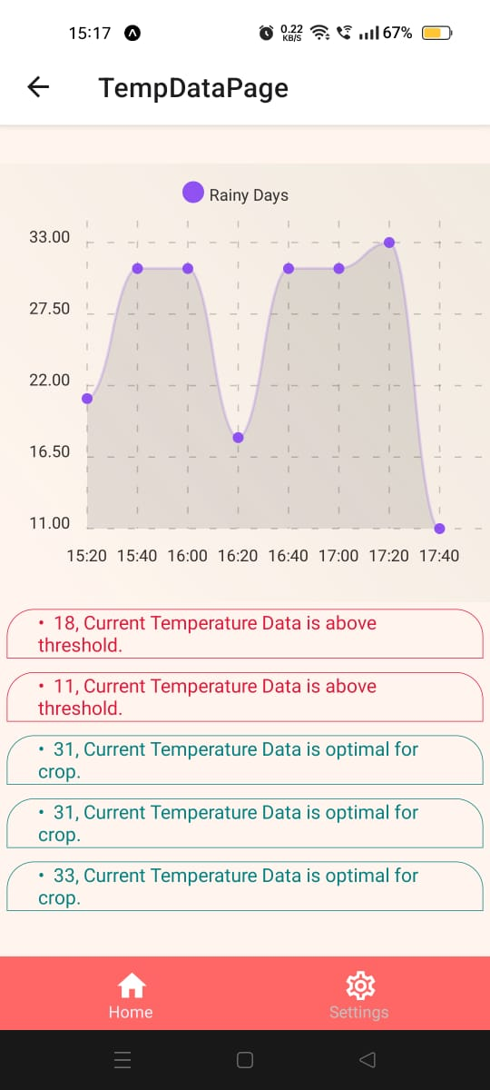 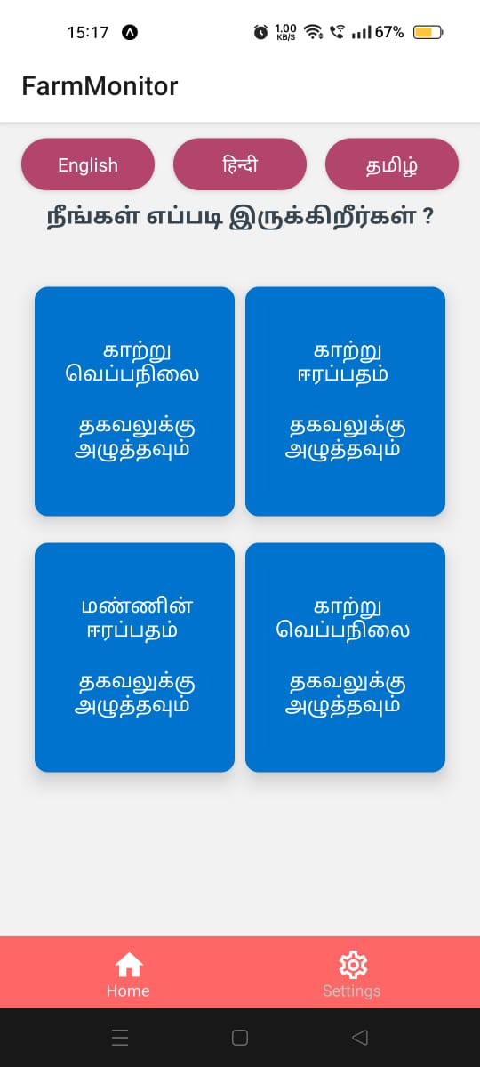

**Hardware Screenshots –**

Our complete product includes sensors such as soil moisture sensor and DHT-11 sensors using the principle of capacitance collects information about the moisture content in the soil. All the data that is collected is then sent for information extraction and interpretation. This is achieved by sending the data to node MCU microcontroller, the microcontroller then checks the data and automates the irrigation process.

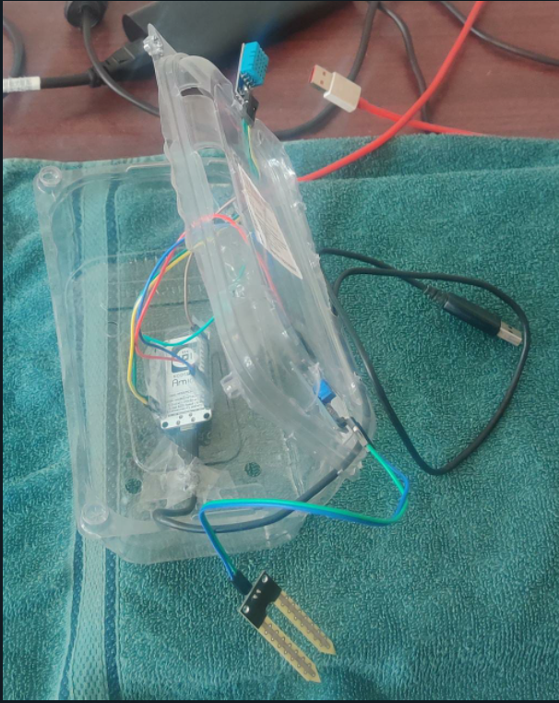 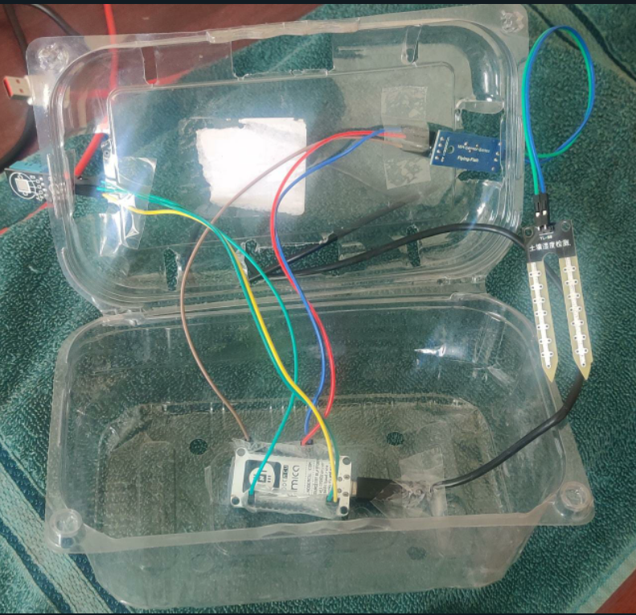

The Wi-Fi module which is built in nodeMCU ESP8266 then used to send the data collected from the sensors to our live database where it is analysed.

The app, which is made in React Native, sends a GET request to the backend, built using Django-Firebase. The backend returns a JSON response of the data, which is used to plot graphs and display analysis to the user.

The app has local language translation in Hindi, English and Tamil.

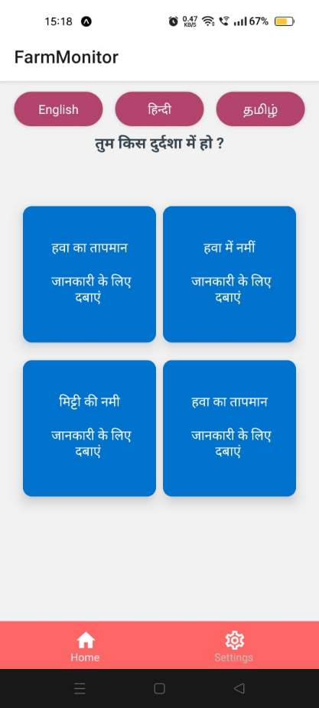 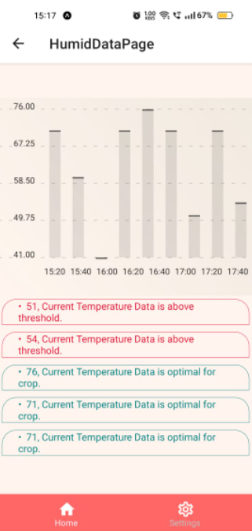

**Power Calculations -**

After performing the power analysis, we can conclude that solar powered batteries are an viable option to power our product. In the field the battery will have plenty of exposure to sun rays which will charge it. A 100Ah battery will power the product for 187 hrs which is approximately 8 days.

|  |  |  |  |  |
| --- | --- | --- | --- | --- |
| Sr. No. | Sensor | Operating Current | Operating Voltage | Power Required |
| 1 | Soil Moisture Sensor | 2 mA | 3.3 V | 6.6 mW |
| 2 | DHT-11 Sensor | 0.5 mA | 3.3 V | 165 mW |
| 3 | ESP8266 | 10 mA | 3.3 V | 33 mW |
| 4 | LED Bulb | 100 mA | 3.3 V | 330 mW |

Therefore, the total power consumption is 534.6 mW.

**Observations –**

The product development phase has been completed. The prototype is ready and is performing the functionalities we had aimed for. The farm monitor is able to capture air temperature, air humidity effectively. Data is being sent using the wifi module to our database and the app accesses the live data and displays it to the user. The soil moisture sensor works satisfactorily but we observed that the soil moisture sensor is prone to corrosion which renders it defective after a short period of time. This problem will need to be solved by in the future by providing a protection layer over the sensor.

**Future Enhancements:**

Ongoing through the research papers, we find that there is still much to improve in our product space. The process of analysis from the data gathered can be made better using Machine Learning and Neural Networks. This will make the analysis more fault tolerant and less susceptible to outside cases and failures.

There is still the issue of lack of network coverage for most farmers. This can be resolved by the help of radio and SMS messages that are still prevalent in the major parts of the country.

We can extend this solution to also check for content of minerals in the soil, thus helping better monitor and control the growth of crops. This can lead to increased productivity.

**Bibliography –**

* Gutiérrez, J., Villa-Medina, J.F., Nieto-Garibay, A. and Porta-Gándara, M.Á., 2013. Automated irrigation system using a wireless sensor network and GPRS module. *IEEE transactions on instrumentation and measurement*, *63*(1), pp.166-176.
* Kodali, R.K. and Sahu, A., 2016, December. An IoT based soil moisture monitoring on Losant platform. In *2016 2nd International Conference on Contemporary Computing and Informatics (IC3I)* (pp. 764-768). IEEE.
* Athani, S., Tejeshwar, C.H., Patil, M.M., Patil, P. and Kulkarni, R., 2017, February. Soil moisture monitoring using IoT enabled arduino sensors with neural networks for improving soil management for farmers and predict seasonal rainfall for planning future harvest in North Karnataka—India. In 2017 International Conference on I-SMAC (IoT in Social, Mobile, Analytics and Cloud) (I-SMAC) (pp. 43-48). IEEE.